**Project documentation**

# 

***(Computer Networking Lab )***

**Muhammad Babar ALI**

*( SU92-BSSEM-F22-065 )*

BSSE – 5B ( 2022 – 2026)

**Department Of Software Engineering**

Submitted to: Sir Rasikh ali

Submitted on: Dec 10,2024

**Faculty Of CS&IT ( Gold Campus ), Superior University, Lahore**

**Bank management system:**

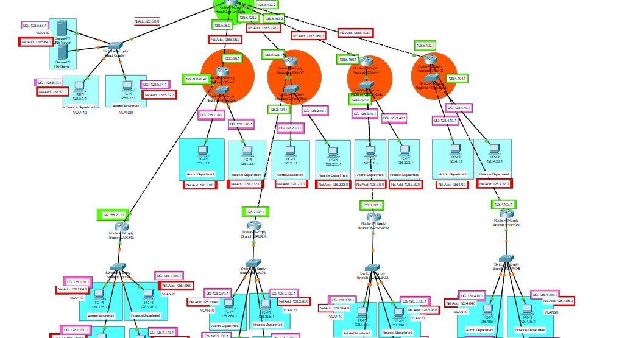

**Documentation:**

## **Bank Management Network System Documentation**

### **1. Overview of the Network**

The provided network topology demonstrates a hierarchical and segmented network infrastructure designed for a bank management system. The network includes:

* **Core Network**: Centralized control and routing.
* **Branch Networks**: Subnetworks for different administrative and finance departments across multiple branches.
* **Server Room**: Hosting DNS servers, file servers, and backup systems.
* **VLAN Segmentation**: Segregation of traffic for security and efficiency.
* **Inter-VLAN Routing**: Routing between different VLANs to facilitate communication.

#### **Network Design Overview**

1. **Head Office:**
   * Consists of three departments:
     + **Admin Department** (VLAN 10)
     + **Finance Department** (VLAN 20)
     + **IT Department** (VLAN 30)
   * Each department has its own VLAN for traffic isolation and efficient management.
   * Uses a Layer 3 switch for inter-VLAN routing.
   * Connected to the regional offices via routers.
2. **Regional Offices:**
   * Each regional office contains two departments:
     + **Admin Department** (VLAN 40)
     + **Finance Department** (VLAN 50)
   * VLANs are used to segregate traffic between departments.
   * Connected to the head office through dedicated point-to-point links.
3. **Branches:**
   * Each branch is connected to a respective regional office.
   * Four branches are configured with VLANs:
     + **Admin Department** (VLAN 60)
     + **Finance Department** (VLAN 70)
   * Each branch communicates with its parent regional office.

#### **IP Addressing and Subnetting**

The network uses a Class B IP address block **128.0.0.0/16**, which is subnetted to provide IP addresses for VLANs and point-to-point links.

1. **Head Office Subnets:**
   * VLAN 10: 128.0.10.0/24
   * VLAN 20: 128.0.20.0/24
   * VLAN 30: 128.0.30.0/24
2. **Regional Offices Subnets:**
   * VLAN 10: 128.0.40.0/24
   * VLAN 20: 128.0.50.0/24
3. **Branches Subnets:**
   * VLAN 10: 128.0.60.0/24
   * VLAN 20: 128.0.70.0/24
4. **Point-to-Point Links (Inter-Router Links):**
   * Example: 128.0.1.0/30, 128.0.1.4/30, etc.

#### **VLAN and Inter-VLAN Routing**

1. VLANs are configured on switches at each location to isolate department-specific traffic.
2. Inter-VLAN routing is implemented using Layer 3 switches and routers.
3. **Router-on-a-Stick Configuration:**
   * Subinterfaces are configured for each VLAN:

bash

Copy code

interface gigabitEthernet 0/0.10

encapsulation dot1Q 10

ip address 128.0.10.1 255.255.255.0

interface gigabitEthernet 0/0.20

encapsulation dot1Q 20

ip address 128.0.20.1 255.255.255.0

#### **Static Routing Configuration**

Static routes are configured to ensure connectivity between the head office, regional offices, and branches. For example:

* On the **Head Office Router**:

bash

Copy code

ip route 128.0.40.0 255.255.255.0 128.0.1.1

ip route 128.0.50.0 255.255.255.0 128.0.1.5

* On the **Regional Office Router**:

bash

Copy code

ip route 128.0.60.0 255.255.255.0 128.0.2.1

ip route 128.0.70.0 255.255.255.0 128.0.2.5

#### **Key Features of the Design**

1. **Scalability:** The use of VLANs and subnetting ensures the network can grow by adding more departments, regional offices, or branches without redesigning the entire network.
2. **Traffic Segmentation:** VLANs provide security by isolating department traffic and minimizing broadcast domains.
3. **Efficient Routing:** Inter-VLAN routing and static routes ensure seamless communication between all locations.
4. **Security:** Departmental separation prevents unauthorized access between VLANs.

#### **Conclusion**

This project successfully demonstrates the design and implementation of a hierarchical computer network using VLANs, subnetting, and static routing. The network is structured to meet the needs of a growing organization, ensuring scalability, security, and efficiency